**Building & Safety Division** │ **Plans and Permits Division**

Development Services Center

39550 LIBERTY STREET, FREMONT, CA 94538

P: 510.494.4443 │ F: 510.494.4820

[WWW.FREMONT.GOV](http://www.fremont.gov/)

**NOTICE TO PROPERTY OWNER**

OWNER-BUILDER ACKNOWLEDGEMENT AND INFORMATION VERIFICATION FORM

TO:

Himanshu Malik

Property Owner

4456 Gina St, Fremont, CA 94538

Mailing Address

BLD 2024-06273

Dear Property Owner:

An application for a building permit has been submitted in your name listing yourself as the builder of the property

improvements specified at 4456 Gina St, Fremont, CA 94538 .

We are providing you with an Owner-Builder Acknowledgment and Information Verification Form to make you aware of your responsibilities and possible risk you may incur by having this permit issued in your name as the Owner-Builder.

We will not issue a building permit until you have read, initialed your understanding of each provision, signed, and returned this form to us at our official address indicated. An agent of the owner cannot execute this notice unless you, the property owner, obtain the prior approval of the permitting authority.

OWNER’S ACKNOWLEDGMENT AND VERIFICATION OF INFORMATION

DIRECTIONS: Read and initial each statement below to signify you understand or verify this information.

HM 1. I understand a frequent practice of unlicensed persons is to have the property owner obtain an “Owner-

Builder” building permit that erroneously implies that the property owner is providing his or her own labor and material personally. I, as an Owner-Builder, may be held liable and subject to serious financial risk for any injuries sustained by an unlicensed person and his or her employees while working on my property. My homeowner’s insurance may not provide coverage for those injuries. I am willfully acting as an Owner-Builder and am aware of the limits of my insurance coverage for injuries to workers on my property.

HM 2. I understand building permits are not required to be signed by property owners unless they are

responsible for the construction and are not hiring a licensed Contractor to assume this responsibility.

HM 3. I understand as an “Owner-Builder” I am the responsible party of record on the permit. I understand that

I may protect myself from potential financial risk by hiring a licensed Contractor and having the permit filed in his

or her name instead of my own.

HM 4. I understand Contractors are required by law to be licensed and bonded in California and to list their

license numbers on permit and contracts.

2024-06272

BLD (cont)

HM 5. I understand if I employ or otherwise engage any persons, other than California licensed Contractors, and

the total value of my construction is at least five hundred dollars ($500), including labor and materials, I may be

considered an “employer” under state and federal law.

HM 6. I understand if I am considered an “employer” under state and federal law, I must register with the state

and federal government, withhold payroll taxes, provide workers’ compensation disability insurance, and contribute

to unemployment compensation for each “employee”. I also understand my failure to abide by these laws may subject me to serious financial risk.

HM 7. I understand under California Contractors’ State License Law, an Owner-Builder who builds single-

family residential structures cannot legally build them with the intent to offer them for sale, unless all work is

performed by licensed subcontractors and the number of structures does not exceed four within any calendar year, or all of the work is performed under contract with a licensed general building Contractor.

HM 8. I understand as an Owner-Builder if I sell the property for which this permit is issued, I may be held

liable for any financial or personal injuries sustained by any subsequent owner (s) that result from any latent

construction defects in the workmanship or materials.

HM 9. I understand I may obtain more information regarding my obligations as an “employer” from the Internal

Revenue Service, the United States Small Business Administration, the California Department of Benefit payments,

and the California Division of Industrial Accidents. I also understand I may contact the California Contractors’ State License Board (CSLB) at 1-800-321-CSLB (2752) or [www.cslb.ca.gov](http://www.cslb.ca.gov/) for more information about licensed contractors.

HM 10. I am aware of and consent to an Owner-Builder building permit applied for in my name, and understand

that I am the party legally and financially responsible for proposed construction activity at the following address:

.

HM 11. I agree that, as the party legally and financially responsible for this proposed construction activity, I will

abide by all applicable laws and requirements that govern Owner-Builders as well as employers.

HM 12. I agree to notify the issuer of this form immediately of any additions, deletions, or changes to any of the

information I have provided on this form.

If you contract with someone who does not have a license, the Contractors’ State License Board may be unable to assist you with any financial loss you may sustain as a result of a complaint. Your only remedy against unlicensed Contractors may be in civil court. It is also important for you to understand that if an unlicensed Contractor or employee of that individual or firm is injured while working on your property, you may be held liable for damages. If you obtain a permit as Owner-Builder and wish to hire Contractors, you will be responsible for verifying whether or not those Constractors are properly licensed and the status of their workers’ compensation insurance coverage. Before a building permit can be issued, this form must be completed and signed by the property owner and returned to the agency responsible for issuing the permit.

*Note: A copy of the property owner’s driver’s license, form notarization, or other verification acceptable to the agency is required to be presented when the permit is issued to verify the property owner’s signature.*

Name of property owner: Himanshu Malik

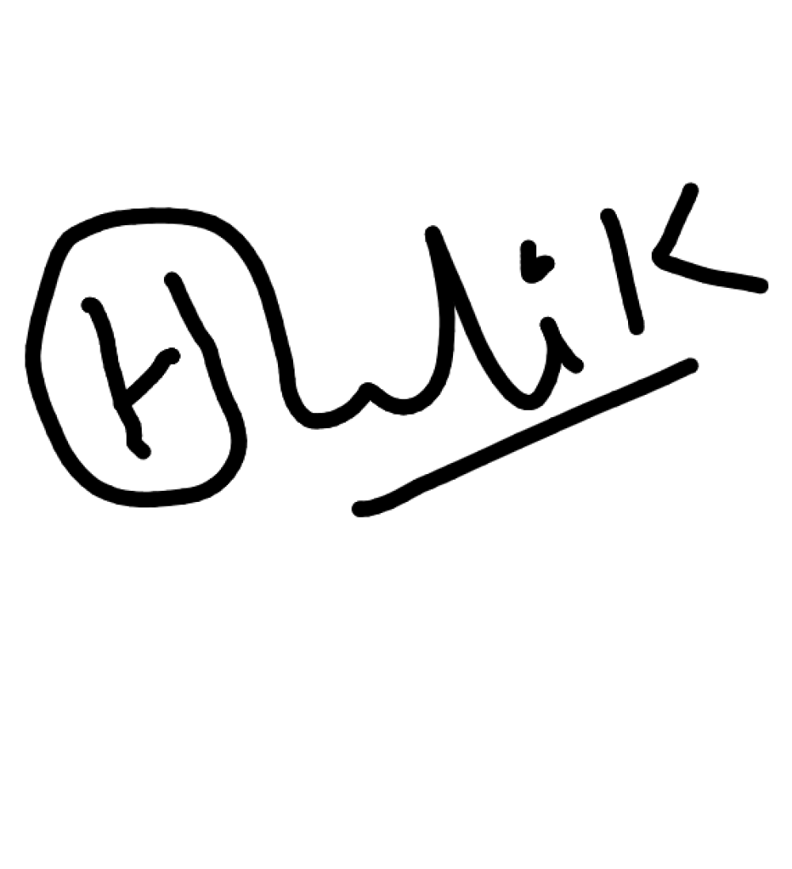

Signature of property owner: Date: 6/26/2024